DevOps

Git

Git track changes via a distributed version control system. This means that Git can track the state of different versions of your projects while you're developing them. It is distributed because you can access your code files from another computer – and so can other developers.

When you're building an open source project, you'll need a way to document or track your code. This helps make your work organized, and lets you keep track of the changes you've made.

Operation of Git

- Manage projects with Repositories

- Clone a project to work on a local copy

- Control and track changes with Staging and Committing

- Branch and Merge to allow for work on different parts and versions of a project

- Pull the latest version of the project to a local copy

- Push local updates to the main project

Experiment A1

A1. Demonstrate and Create project in local and remote repository using GitBash and GitHub and apply init, status, log, add, commit, push, config, clone and reset commands on repository.
Git Init command

This command is used to create a local repository.

Syntax
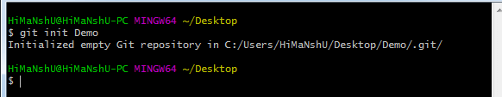
- $ git init Demo

Git status command

The status command is used to display the state of the working directory and the staging area. It also lists the files that you've changed and those you still need to add or commit.

Syntax
1. $ git status
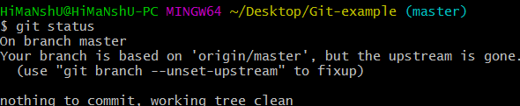

Git log Command

This command is used to check the commit history.

Syntax
1. $ git log
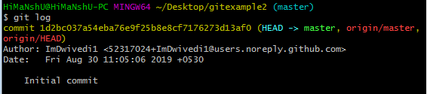

By default, if no argument passed, Git log shows the most recent commits first. We can limit the number of log entries displayed by passing a number as an option, such as -3 to show only the last three entries.

Git add command

This command is used to add one or more files to staging (Index) area.

Syntax

To add one file
1. $ git add Filename To add more than one file
1. $ git add*

Git commit command

Commit command is used in two scenarios. They are as follows.

Git commit -m

This command changes the head. It records or snapshots the file permanently in the version history with a message.

Syntax
1. $ git commit -m " Commit Message"
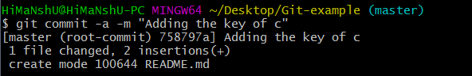

Git push Command

It is used to upload local repository content to a remote repository. Pushing is an act of transfer commits from your local repository to a remote repo. It's the complement to git fetch, but whereas fetching imports commits to local branches on comparatively pushing exports commits to remote branches.

Syntax
- $ git push [variable name] master
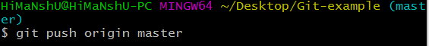

Git config command

This command configures the user. The Git config command is the first and necessary command used on the Git command line.

Syntax
- $ git config --global user.name "ImDwivedi1"
- $ git config --global user.email "Himanshudubey481@gmail.com"
Git clone command

This command is used to make a copy of a repository from an existing URL. If I want a local copy of my repository from GitHub, this command allows creating a local copy of that repository on your local directory from the repository URL.

Syntax
- $ git clone URL
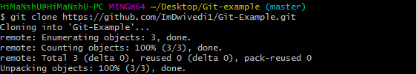

Git Reset

The term reset stands for undoing changes. The git reset command is used to reset the changes.
- $ git reset --hard

Consider the below output:

Experiment A2

A2. Demonstrate to create a project in remote repository and apply fork, merge, diff, merge conflict, branch and pull request concepts on repository using GitHub.
Git Fork

A fork is a rough copy of a repository. Forking a repository allows you to freely test and debug with changes without affecting the original project.
It is a straight-forward process. Steps for forking the repository are as follows:

  - Login to the GitHub account.

  - Find the GitHub repository which you want to fork.

  - Click the Fork button on the upper right side of the repository's page.
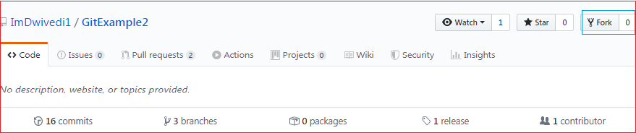

Git Merge
In Git, the merging is a procedure to connect the forked history. It joins two or more development history together. The git merge command facilitates you to take the data created by git branch and integrate them into a single branch.
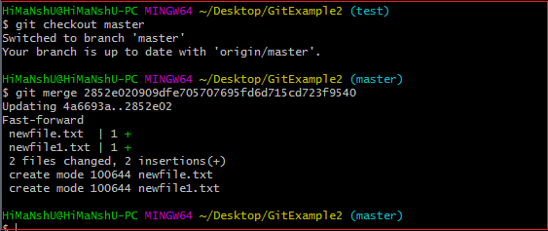
1. $ git merge master See the below output:

Git Diff

It compares the different versions of data sources. The version control system stands for working with a modified version of files. So, the diff command is a useful tool for working with Git.
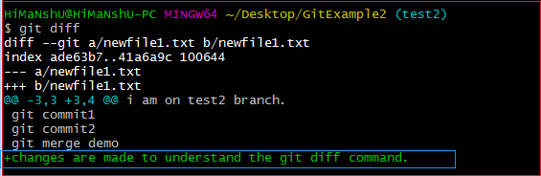

Git Merge Conflict

When two branches are trying to merge, and both are edited at the same time and in the same file, Git won't be able to identify which version is to take for changes. Such a situation is called merge conflict.
$ mkdir git-merge-test

$ cd git-merge-test

$ git init .

$ echo "this is some content to mess with" > merge.txt

$ git add merge.txt

$ git commit -am"we are commiting the inital content"

[main (root-commit) d48e74c] we are commiting the inital content 1 file changed, 1 insertion(+)
create mode 100644 merge.txt

$ git checkout -b new_branch_to_merge_later

$ echo "totally different content to merge later" > merge.txt

$ git commit -am"edited the content of merge.txt to cause a conflict" [new_branch_to_merge_later 6282319] edited the content of merge.txt to cause a conflict 1 file changed, 1 insertion(+), 1 deletion(-)

$ git merge new_branch_to_merge_later Auto-merging merge.txt
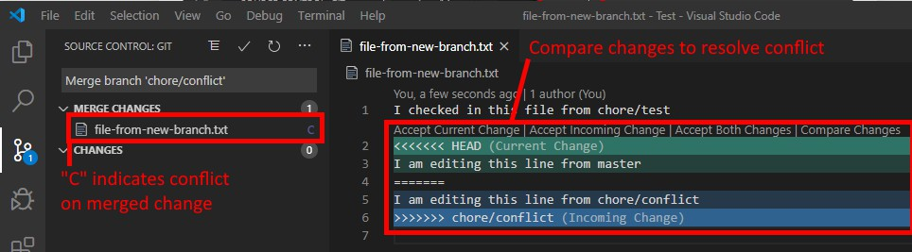
CONFLICT (content): Merge conflict in merge.txt
Automatic merge failed; fix conflicts and then commit result

Git Pull

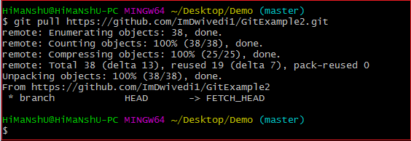
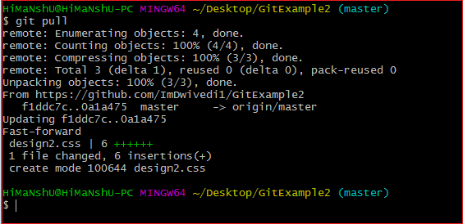
The term pull is used to receive data from GitHub. It fetches and merges changes from the remote server to your working directory. The git pull command is used to pull a repository.

Git Branch

A branch is a version of the repository that diverges from the main working project. It is a feature available in most modern version control systems. A Git project can have more than one branch.
Create Branch

You can create a new branch with the help of the git branch command. This command will be used as:

Syntax:
1. $ git branch <branch name> OUTPUT:

List Branch

You can List all of the available branches in your repository by using the following command.
1. $ git branch --list

OUTPUT:
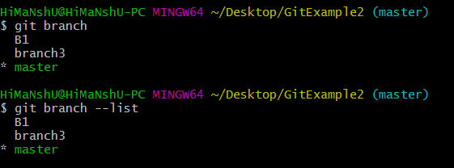

1. $ git branch -d <branch name> Output:
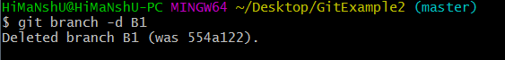

Experiment A3

A3. Demonstrate the process of integration github repository with Jenkins to automate the project execution in CI/CD pipeline.
    - Install Jenkins on Windows
    - Install Java Development Kit (JDK)
    - Download JDK 8 and choose windows 32-bit or 64-bit according to your system configuration. Click on "accept the license agreement." Set the Path for the Environmental Variable for JDK.
    - Go to System Properties. Under the "Advanced" tab, select "Environment Variables."

    - Under system variables, select "new." Then copy the path of the JDK folder and paste it in the corresponding value field. Similarly, do this for JRE.
    - Under system variables, set up a bin folder for JDK in PATH variables.
    - Go to command prompt and type the following to check if Java has been successfully installed:
    - Download and Install Jenkins
    - Download Jenkins. Under LTS, click on windows.

    - After the file is downloaded, unzip it. Click on the folder and install it. Select "finish" once done.
  - Run Jenkins on Localhost 8080

    - Once Jenkins is installed, explore it. Open the web browser and type "localhost:8080".

    - Enter the credentials and log in. If you install Jenkins for the first time, the dashboard will ask you to install the recommended plugins. Install all the recommended plugins.

    - Jenkins Server Interface

    - New Item allows you to create a new project.

    - Build History shows the status of your builds.

    - Manage System deals with the various configurations of the system.

    - Build and Run a Job on Jenkins

    - Select a new item (Name - Jenkins_demo). Choose a freestyle project and click Ok.

    - Under the General tab, give a description like "This is my first Jenkins job." Under the "Build Triggers" tab, select add built step and then click on the "Execute Windows" batch command.
    - In the command box, type the following: echo "Hello... This is my first Jenkins Demo:
    - %date%: %time% ". Click on apply and then save.

    - Select build now. You can see a building history has been created. Click on that. In the console output, you can see the output of the first Jenkins job with time and date. Project configuration
  - Install python interpreter on local machine.

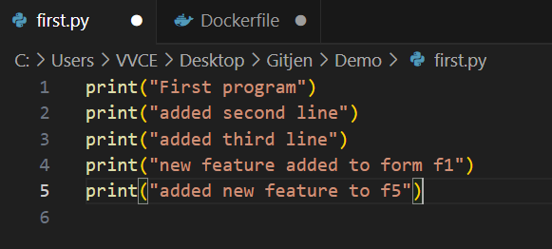
  - Write python script and debug the program for any errors.

  - Push the project into git repository.
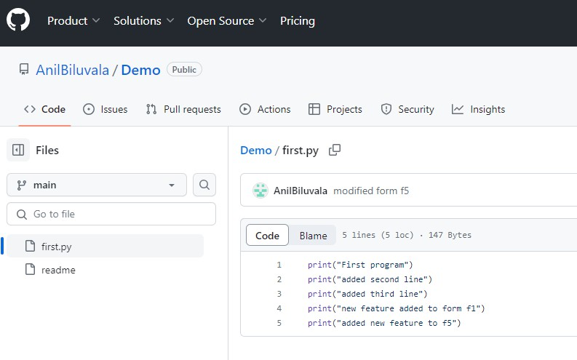

4. Launch the jenkins and configure the pipeline.

Configuration of Jenkins

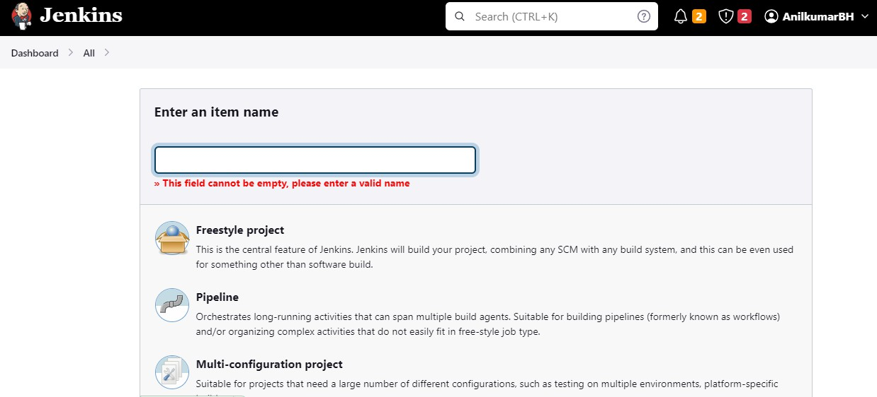
- Create new project and provide name for the project. Choose “Freestyle Project”.

- Click on newly created project and move to configuration. Under source Code Management provide git repository.
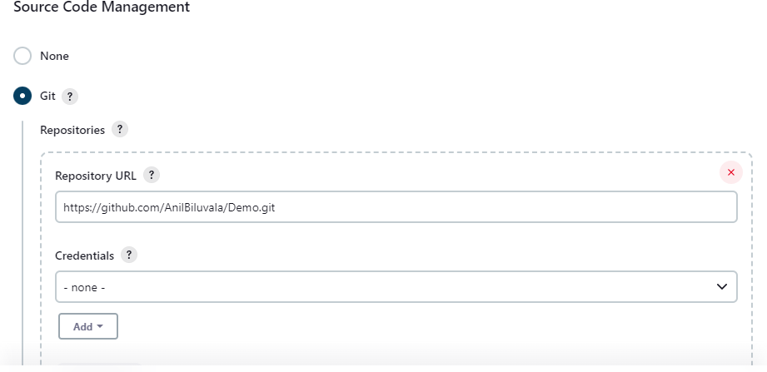

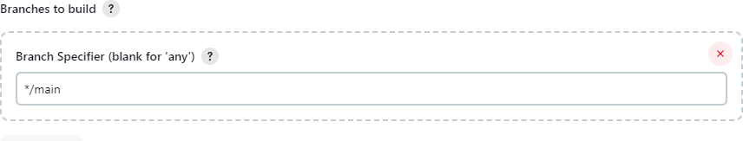
3. Provide branch name where project is located.

- Under Build Triggers select Poll SCM and configure the schedule according to your project.
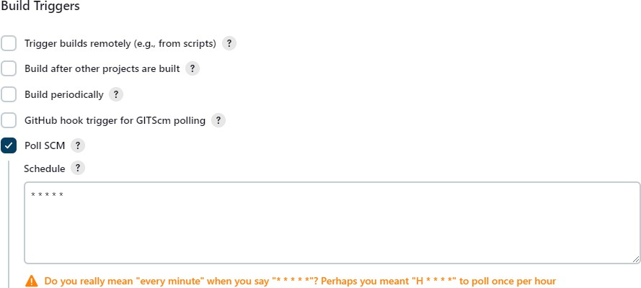

- In build steps choose “Execute Windows batch command” and provide command for execution.
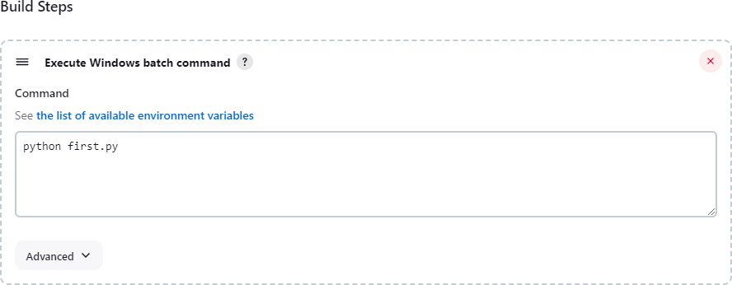

- Apply and save your configuration.

- Click on “Build Now” for detailed output click on “Console Output” and verify the process. Finally build status will be displayed according to your project implementation.

Experiment B1

B1. Create a docker image for an application stored in local repository and run the application using docker image.
Introduction to Docker
Docker is an open platform for developing, shipping, and running applications. Docker enables
you to separate your applications from your infrastructure so you can deliver software quickly. With Docker, you can manage your infrastructure in the same ways you manage your applications. By taking advantage of Docker's methodologies for shipping, testing, and deploying code, you can significantly reduce the delay between writing code and running it in production.
Docker architecture

Docker uses a client-server architecture. The Docker client talks to the Docker daemon, which does the heavy lifting of building, running, and distributing your Docker containers. The Docker client and daemon can run on the same system, or you can connect a Docker client to a remote Docker daemon. The Docker client and daemon communicate using a REST API, over UNIX sockets or a network interface. Another Docker client is Docker Compose, that lets you work with applications consisting of a set of containers.
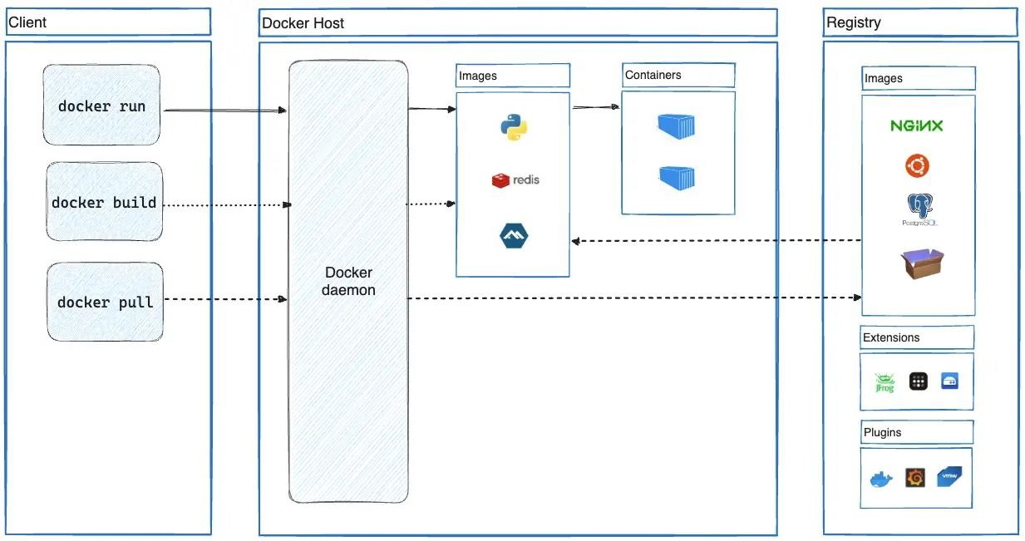

Install Docker Desktop on Windows System requirements

- WSL version 1.1.3.0 or later.
- Windows 11 64-bit: Home or Pro version 21H2 or higher, or Enterprise or Education version 21H2 or higher.
- Windows 10 64-bit:
- We recommend Home or Pro 22H2 (build 19045) or higher, or Enterprise or Education 22H2 (build 19045) or higher.
- Minimum required is Home or Pro 21H2 (build 19044) or higher, or Enterprise or Education 21H2 (build 19044) or higher.
- Turn on the WSL 2 feature on Windows. For detailed instructions, refer to the Microsoft documentationopen_in_new.
The following hardware prerequisites are required to successfully run WSL 2 on Windows 10 or Windows 11:
- 64-bit processor with Second Level Address Translation (SLAT)open_in_new
- 4GB system RAM
- Enable hardware virtualization in BIOS. For more information, see Virtualization. Configuration of Java applications
- Install prerequisites for java applications like jdk tool.

- Configure environment variables for jdk.
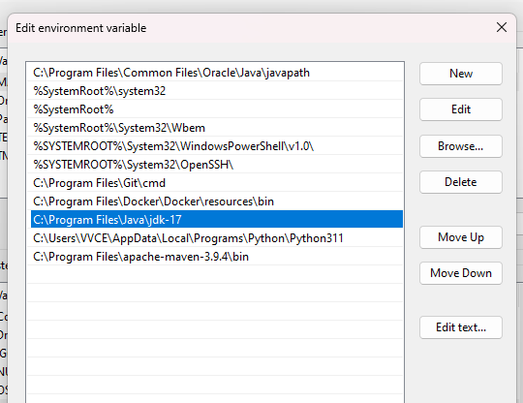

- Create java application.
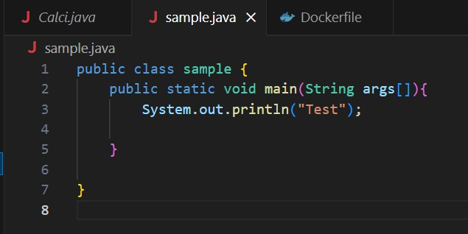

- Create Dockerfile where configuration details are provided for creating image.
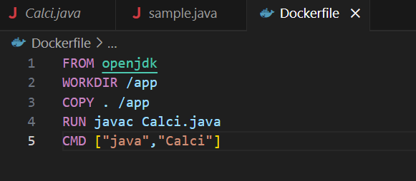

- Complile the java program for any errors.

- Create image for the application.
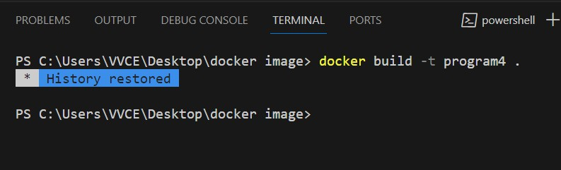

- Run the application using docker image.
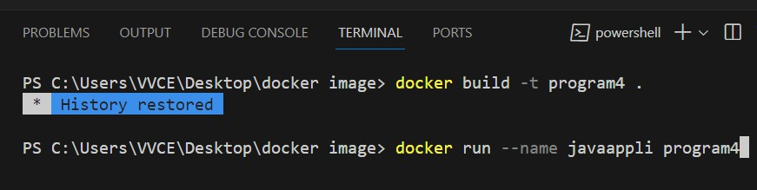

Experiment B2

B2. Create a process to dockerize the image for mysql database, demonstrate the working of client and server model using docker.

This program is to demonstrate pipeline within the application. Mysql image contains built in client and server.
Procedure:

- Run docker desktop application.

- Go to command prompt and search mysql image in hub.
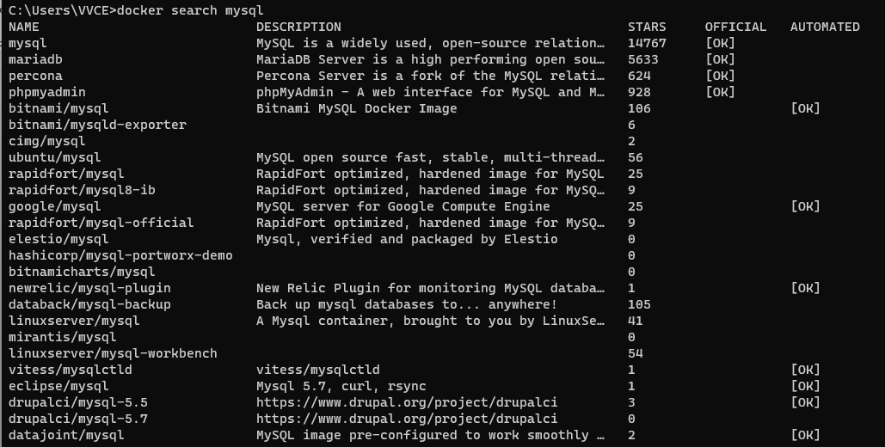

- Pull the image from hub.

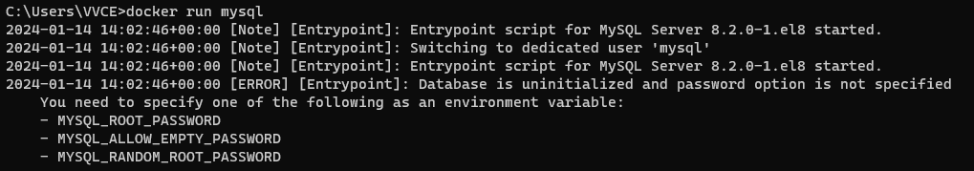
- Run the image

- Configure password form mysql server

-e -> setting environment variable “MYSQL_ROOT_PASSWORD”

-d-> detach running in background.

- Open another tab run client using linux command.
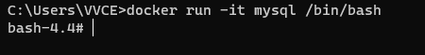

- Required ip address of server to login from clinet. Inspec the server model.
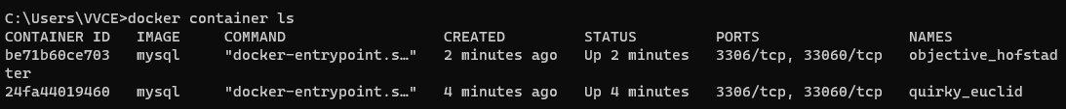

- Inspect contianer based on names

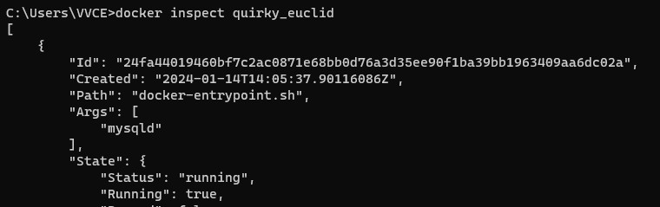

- Note down the server ip address and in clinet enter in to server

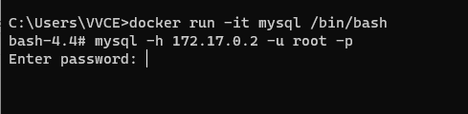
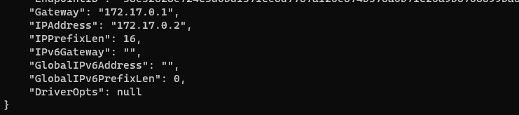

- Logged in from client.

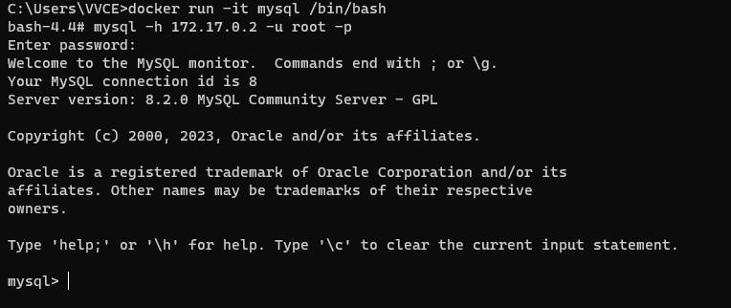

Experiment B3

B3. Create and configure Jenkins files for workflow and build of an application and push the image on docker hub.
Configuration Steps:

- Go to Jenkins and configure docker plug-ins.

Install

  - CloudBees Docker Custom Build EnvironmentVersion1.7.3

  - Docker

  - Docker Compose Build Step

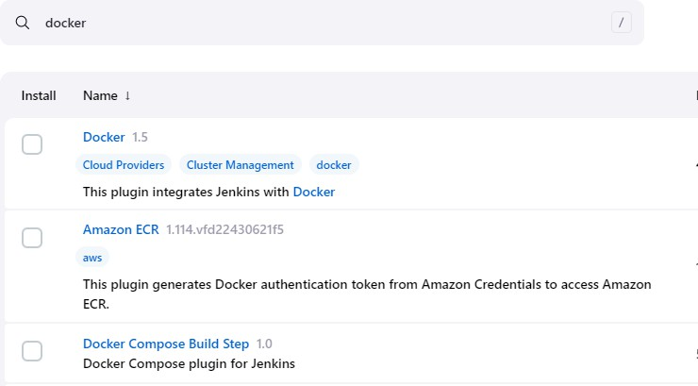
Make sure that these three plug-in must be installed.

- Create a pipeline project
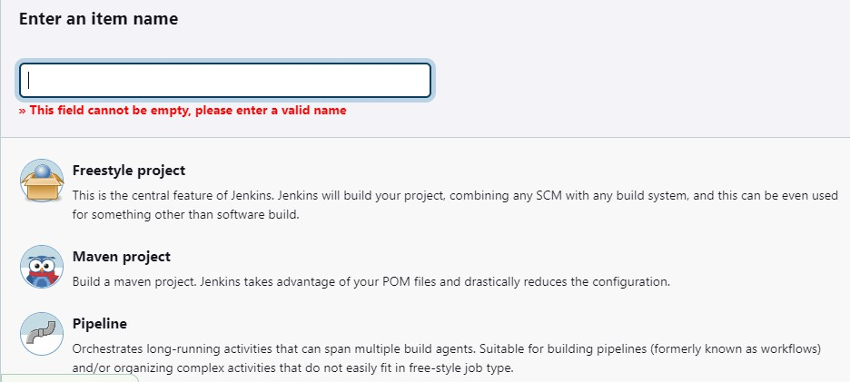

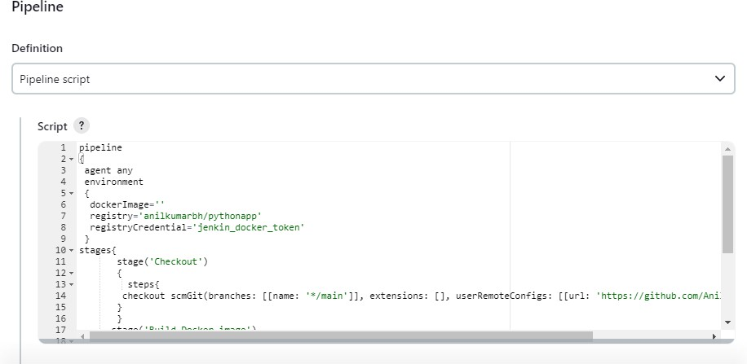
- Go to project configuration add pipeline script under “Advanced project Options”

pipeline
{
agent any environment
{
dockerImage='' registry='anilkumarbh/pythonapp' registryCredential='jenkin_docker_token'
}
stages{
stage('Checkout')
{
steps{
checkout scmGit(branches: [[name: '*/main']], extensions: [], userRemoteConfigs: [[url: 'https://github.com/AnilBiluvala/dpipeline.git']])
}
}
stage('Build Docker image')
{
Steps
{
script
{
dockerImage=docker.build registry
}
}
}

}
}

In script add git url, docker hub credentias, docker hub image name.
Save the configuration and run the build. Image will be created.

- Push the image to docker hub.
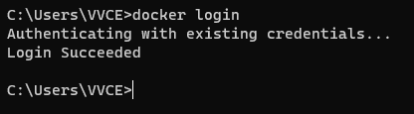

Provide docker hub crdentials.

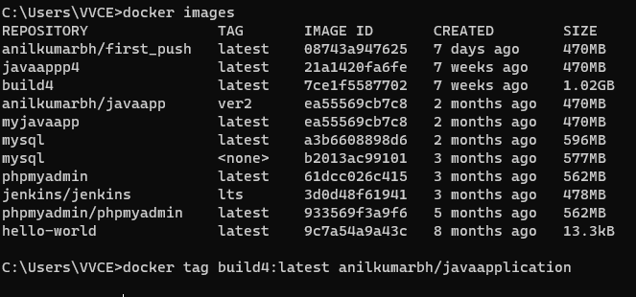
- Tag the image to be pushed.

docker tag <reponame>:<tagname> <hubname>/<display name>

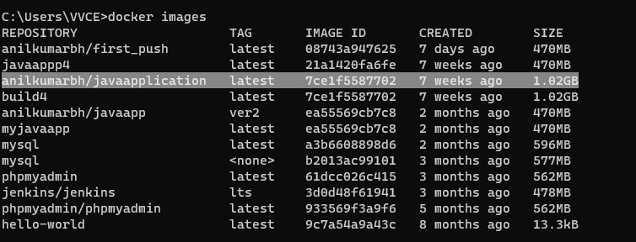

- Push the image to hub.
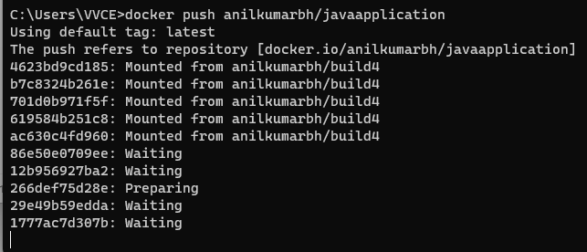

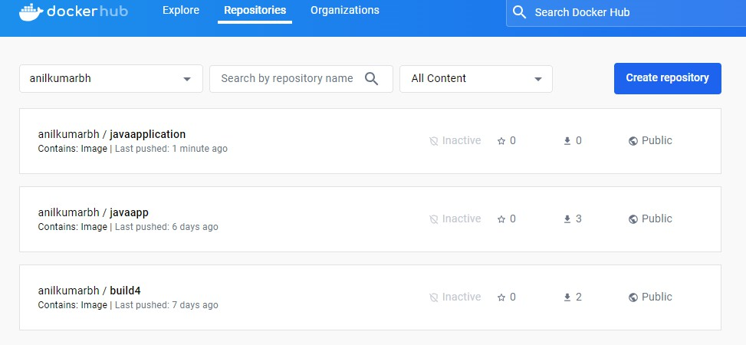
- Image will be available in docker hub.

Experiment C1

C1. Create a maven projects with all dependencies required for the application in CI/CD pipeline.
Required tools:

- Eclipse IDE

- Maven repository

- JSON

Reading data from JSON file. Create JSON file
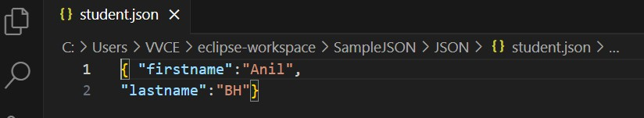

Save the data.

- Create maven project

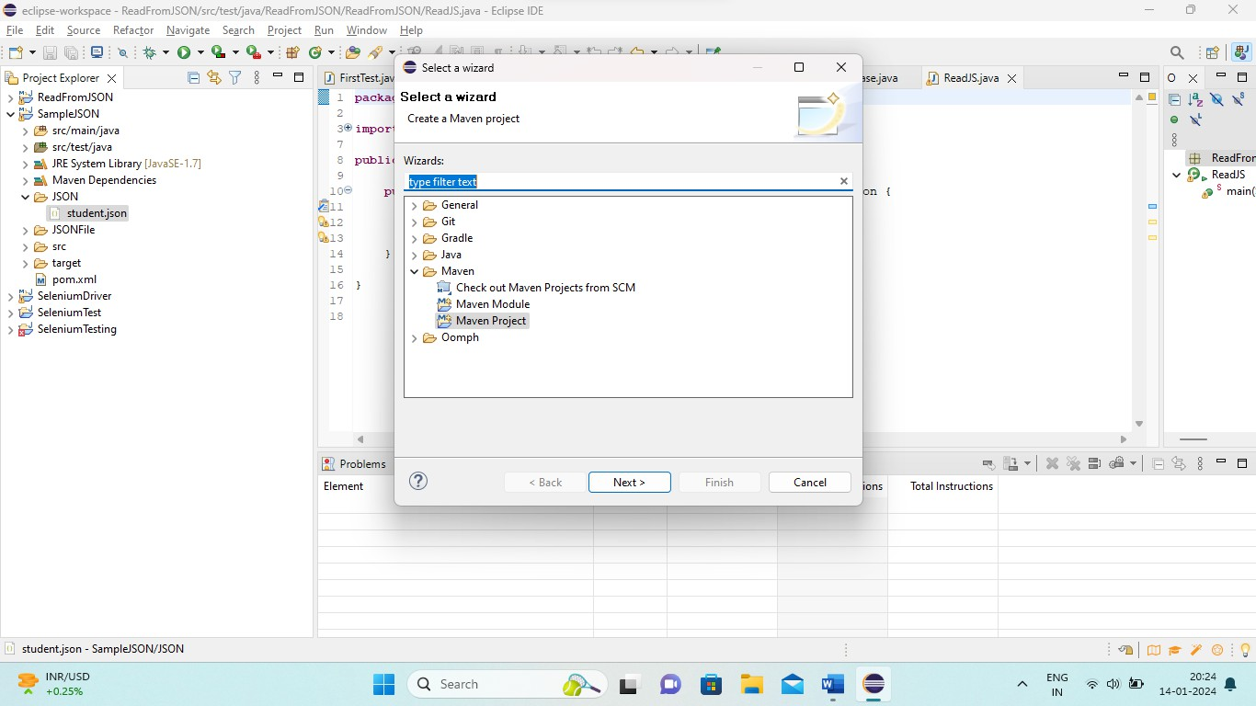
New Project -> Others -> select maven project

Provide project name

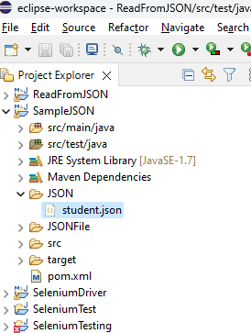
- Create folder “JSON” and add .json file to it.

- Adding JSON dependency to the project in POM.xml file.

Procedure to add dependency Step1 : Go to maven repository Stept2 : search simple json

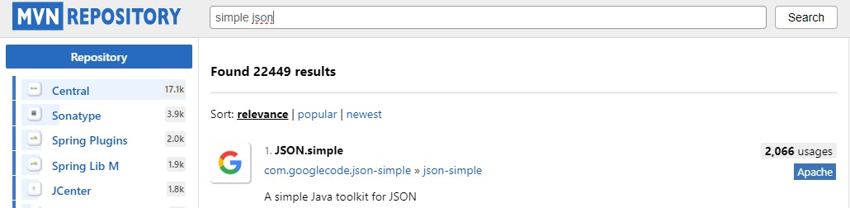

Step3 : choose relevant based on highest usages. Setp4: choose version
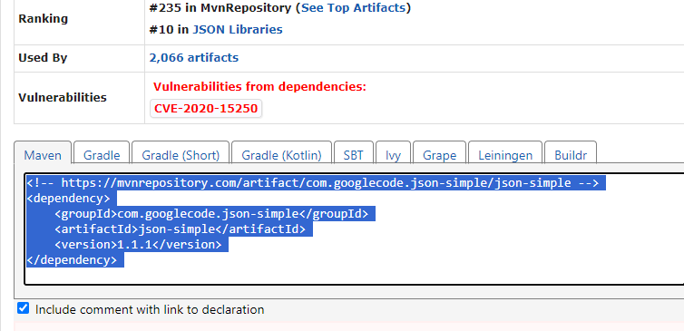
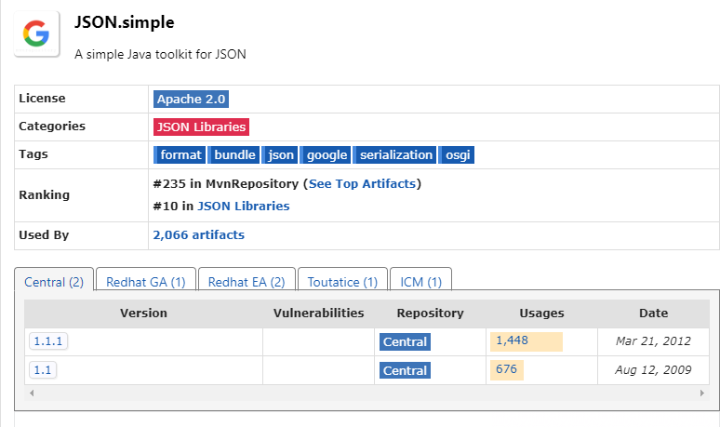
Stept5: copy the dependency.

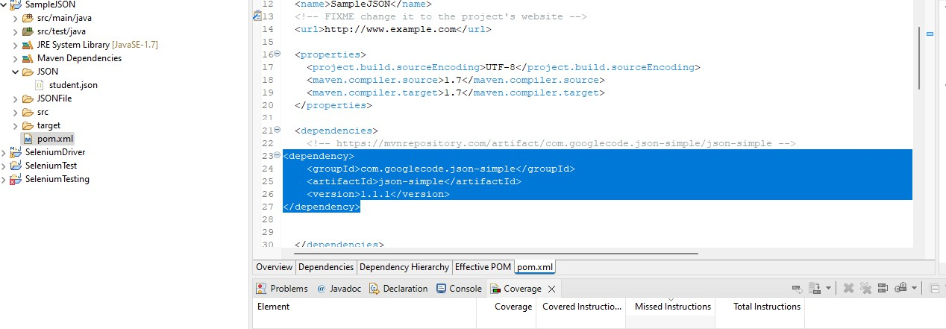
Step6: Open POM.xml and add dependency.

Program to read data from JSON. Create a class under src/test/java
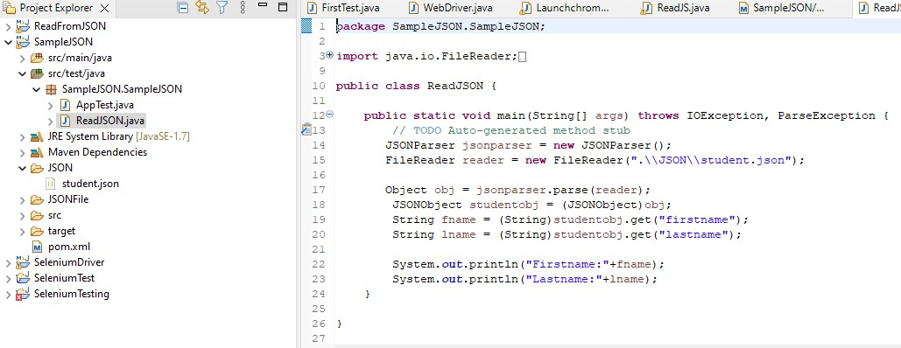

Run the program it will fetch data from JSON file

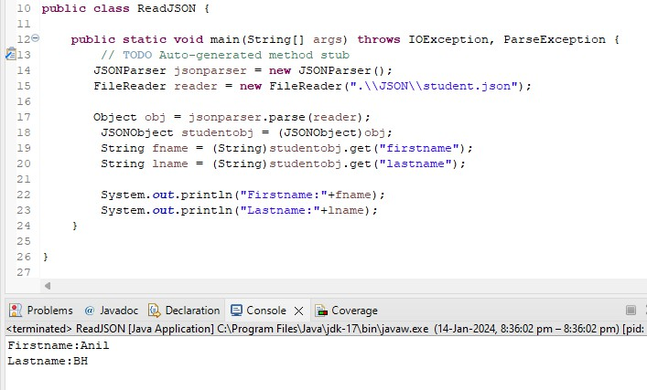

Experiment C2

C2. Integrate communication channel with Jenkins for status of project and also enable email notification for a build.
Communication Channel : Slack Slack installation :
- Install slack application. Create account in slack.
- Create new workgroup or use existing workgroup, add new channel under group.

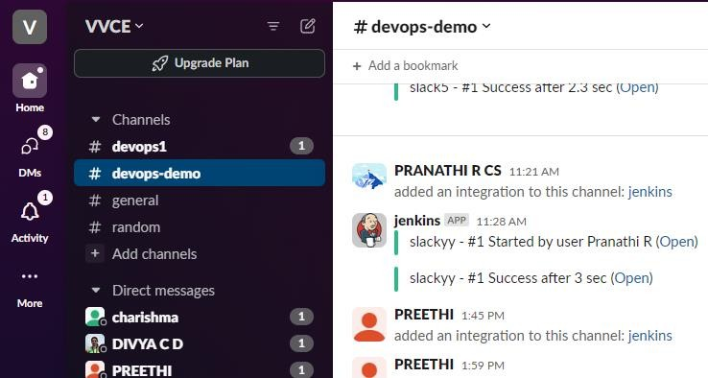

Jenkins configuration:
- Add slack notifications plug-in in jenkins.
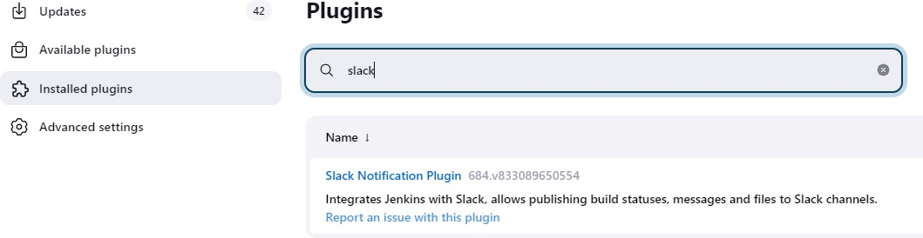

- Click on installed plug-in
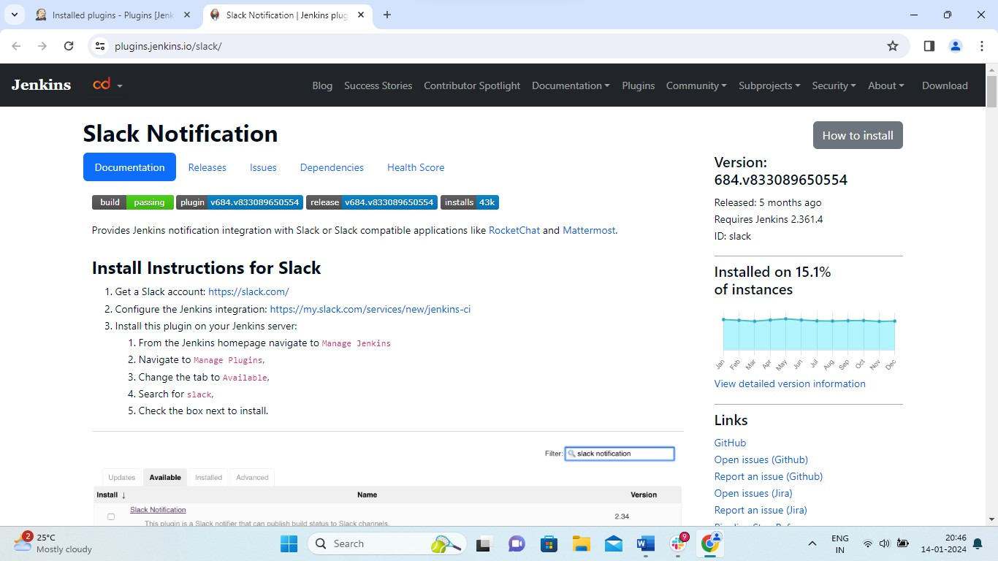
It will redirect to notifications page

- click on “Configure the Jenkins integration:” choose posting channel
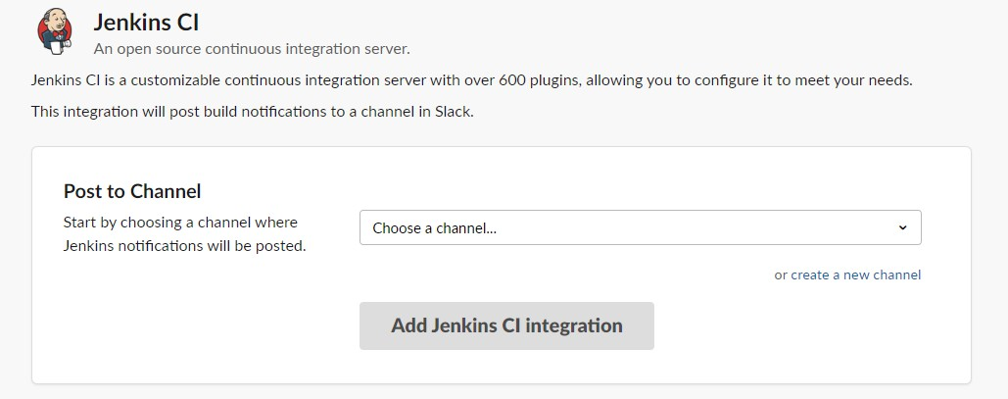

- after choosing channel it will redirec to next page and note down “Integration Token Credential ID”.

- Create free style project.
- Confiugation of project:

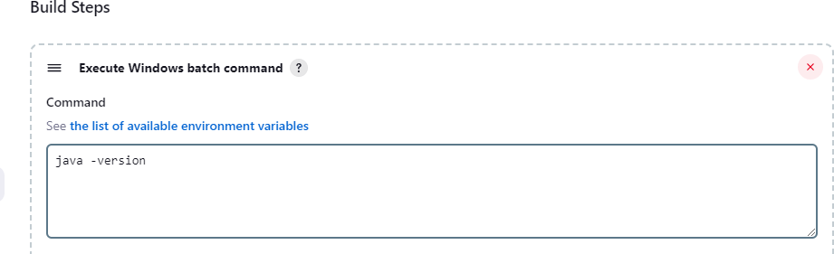

- Add post build action and choose notifications.
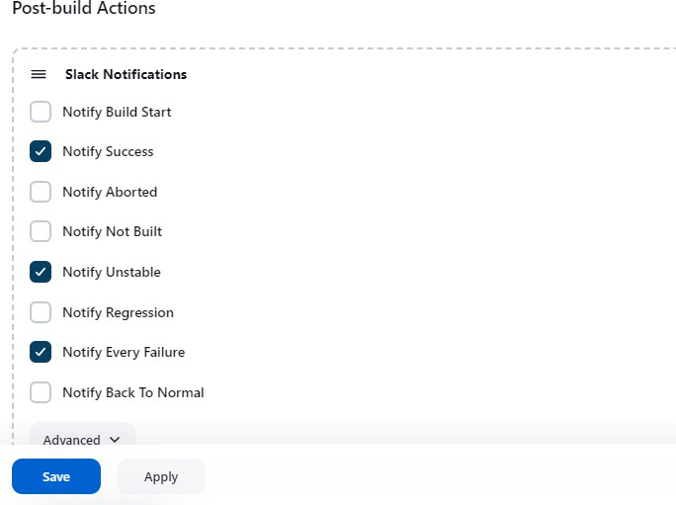

- Save the configuration and run the build.

- Notification will be triggered from jenkins. User will get the notification in channel.

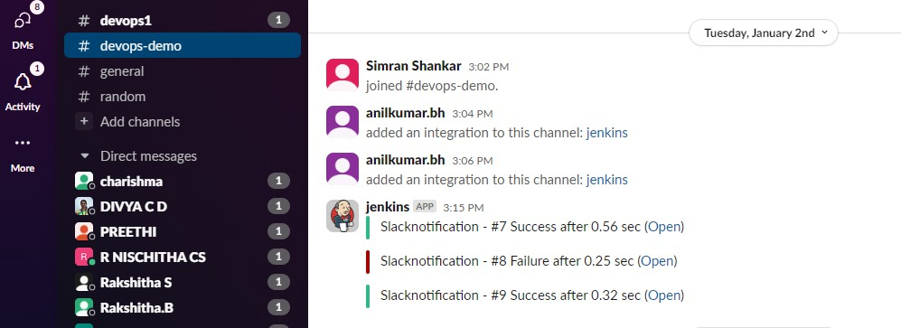
Experiment C3

C3. Apply Xpath to locate elements in an application for automation testing in CI/CD pipeline.
Required tools:

- Selenium

- Eclipse IDE

- Browser for automation.

Procedure:

  - Downloading selenium webdriver, and choose the programming language : java

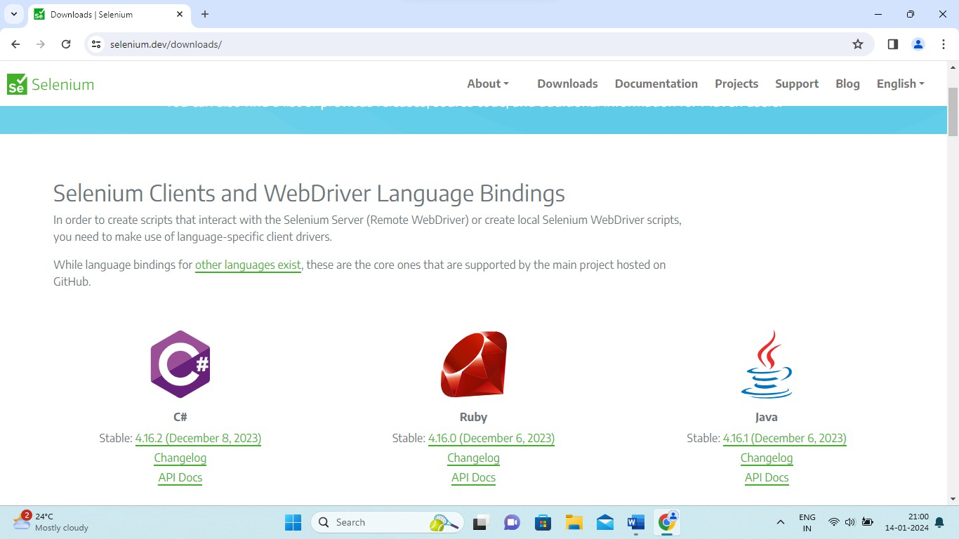

  - Select platform supported by selenium webdriver. Choose appropriate browser: chrome
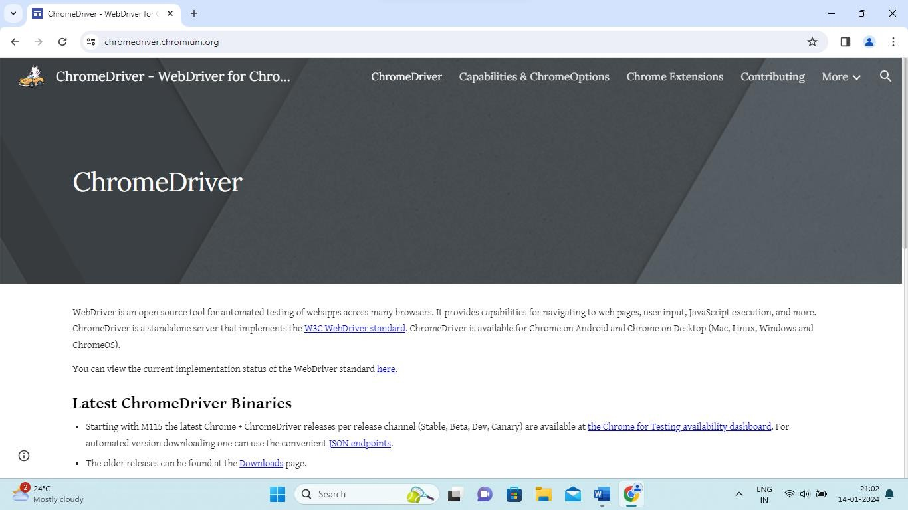

  - Click on “The older releases can be found at the Downloads page.”

  - Find out the version of your browser
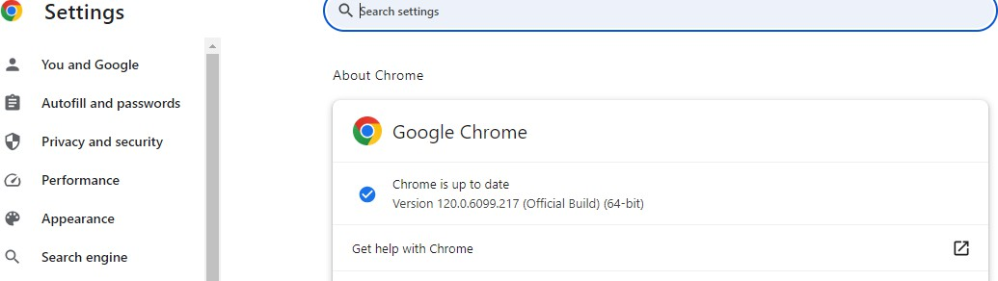

Choose webdrive based on version

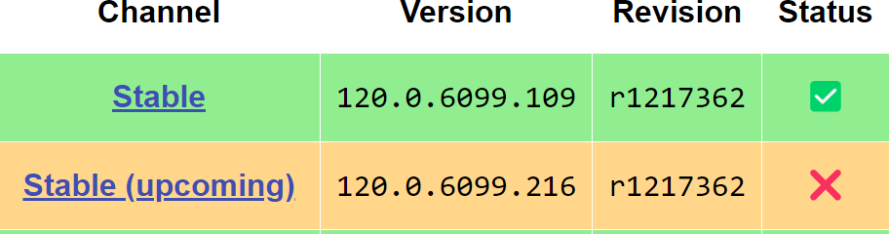

Download the perticular version driver. Project configuration in Eclipse: Step1: Create a Java project.
Step2: Add external jar files to project
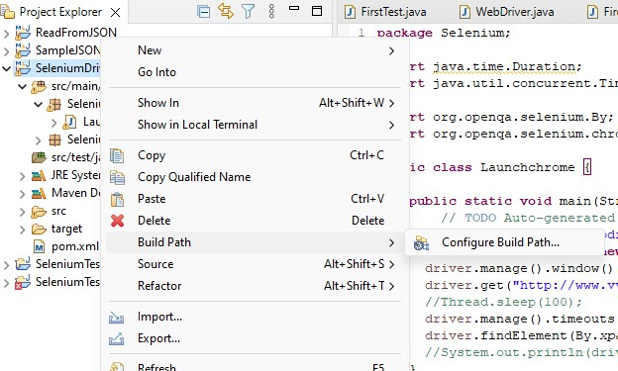
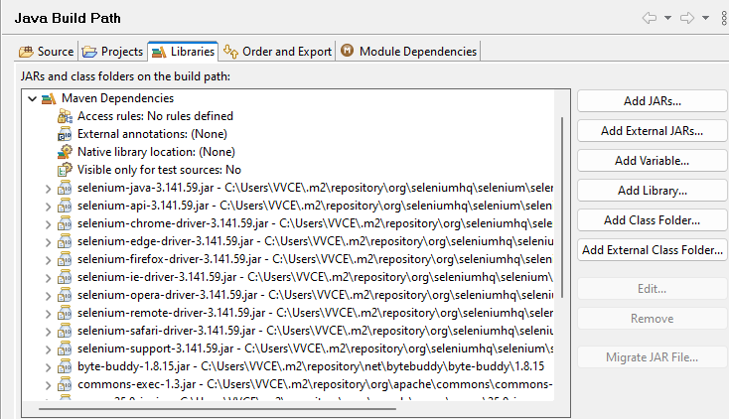

Step3: Save the configuration.

Step4: Create class under “ src/main/”
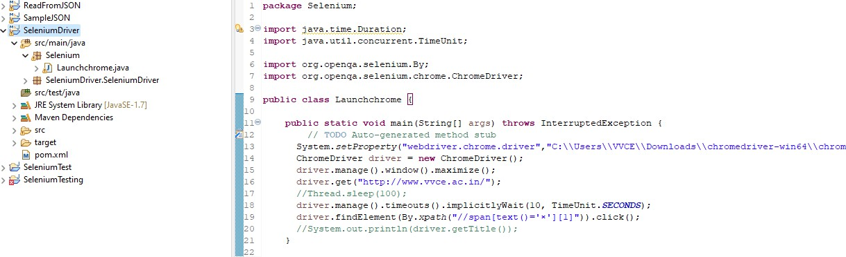
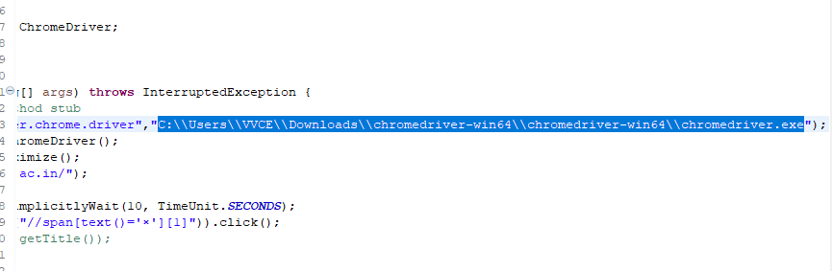
Step5: add chromedriver path

Step6: Save the project.

About Xpath:

- Absolute XPath: Begins from the root of the HTML document and specifies the complete path to the element. It's not as flexible and can break if the page structure changes.
- Relative XPath: Starts from a specific element and navigates through the DOM hierarchy to locate the desired element.
Relative Xpath:
//<Tag Name>[Type of element =”value”][indexing]

Example:

//span[text()=’x’][1] xpath for close popup. Step7: Run the application.
